**B. Studies and Results**

*B.1. Covalent SARS-CoV-2/MERS-CoV Mpro inhibitors*

We’ve taken several approaches utilizing various electrophiles to derivatize covalent inhibitors based on preliminary reversible hits.

*B.1.1. Using Methacrylamide Chemistry*

As part of the Covid Moonshot we have made an acrylamide derivative of a reversible SARS2 Mpro ligand and showed it is able to covalently label the active site Cysteine (PMID: [37943932](https://pubmed.ncbi.nlm.nih.gov/37943932/)). This type of compound, however, did not translate to cellular activity, probably due to stability issues. To maintain covalency while improving compound stability, we switched the electrophile to our recently reported methacrylamide chemistry (ASAP-0000146; Fig. 1; PMID: [34817989](https://pubmed.ncbi.nlm.nih.gov/34817989/), [33761747](https://pubmed.ncbi.nlm.nih.gov/33761747/)). This gave a modest improvement in activity, while maintaining the irreversible interaction, and displaying respectable Kinact/Ki of ~103 M-1s-1. Retaining a similar electrophile, but moving to a higher affinity recognition motif (ASAP-0008466) improve IC50 6-fold to 60 nM. At this point we employed high-throughput nanomole scale chemistry to identify the best amide substituent on the right-hand side of the molecule. We reacted close to 800 amines at that position, and screened crude mixtures biochemically. **The top identified hit (ASAP-0011656) showed an IC50 of 30nM as a crude mixture and 12nM after purification** (5-fold improvement over the aniline parent). We should note that upon covalent binding to the active site the left-hand side of the molecule is released (as assessed by intact protein LC/MS with recombinant protein) and should be able to inhibit another copy of the target non-covalently. The best compound and a close analog (ASAP-0014649) were tested in cellular anti-viral assays (HeLa-ACE2) and showed EC50s in the 0.5-1μM range. The discrepancy between biochemical activity and cellular activity could be related to permeability and is currently investigated.

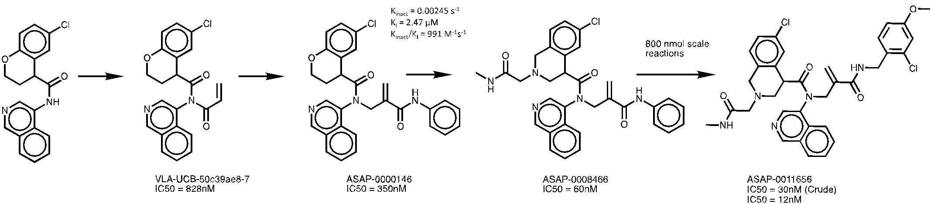

**Figure 1. Progression of a covalent SARS2-Mpro inhibitor from an early reversible hit to a potent irreversible binder.**

*B.1.2. Using Sulfamate Acetamides*

We have recently reported sulfamate acetamides as a new electrophile suitable for covalent drug discovery (PMID: [36738297](https://pubmed.ncbi.nlm.nih.gov/36738297/)). It maintains the geometry of chloroacetamides, which are prevalent probes in chemical biology, but are considered unsuitable for therapeutics due to reactivity and stability issues. We focused on a chloroacetamide discovered in the Covid Moonshot (Fig. 2), and tested a panel of sulfamate replacements. A morpholine sulfamate proved the most potent with >10-fold improvement in IC50 to 60nM. We then proceeded to optimize the right-hand side, and identified a cyclic sulfone that improved both solubility as well as potency to <5nM IC50, which is currently our biochemical assay wall. Upon re-testing the IC50 decreased, suggesting the compounds were instable, reactivity assessment also showed that these sulfamates, contrary to previous examples were more reactive than the chloroacetamide, we therefore reverted back to the chloroacetamide, with the improved recognition element and see that we kept the recognition gains with IC50=55nM representing a 14-fold improvement over the parent compound. We have tried to replace the chloroacetamide with other electrophiles including propynamide, butynamide, acrylamide, bi-ciclo-butanamide and cyanamide – but none were able to regain activity. 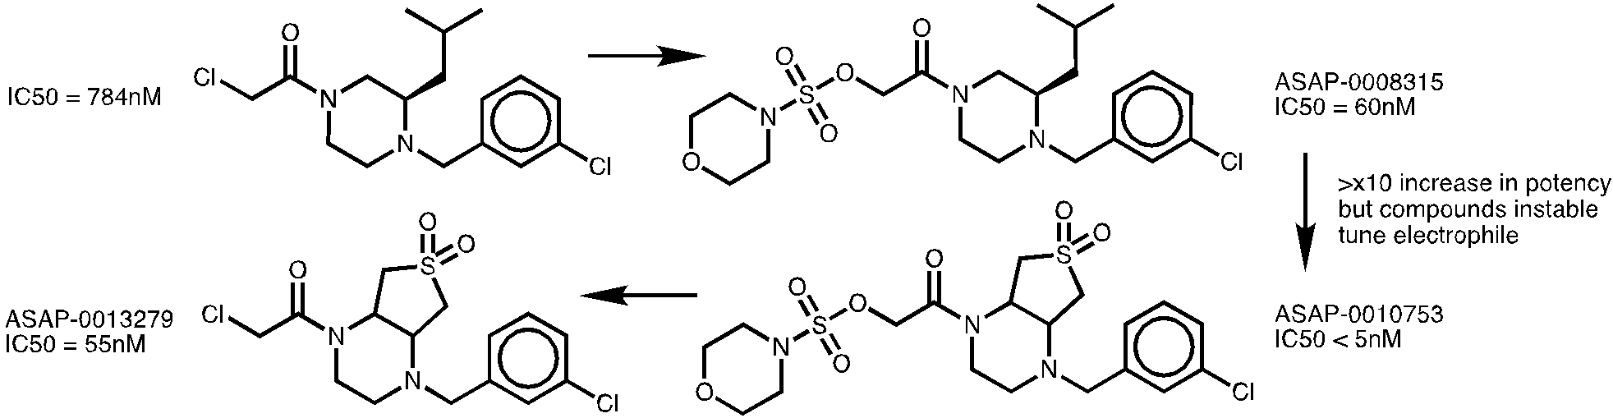

*B.1.3. Dual SARS2/MERS inhibition using Acrylamides*

Building on various reversible SARS2 Mpro inhibitors reported by the Covid Moonshot, we installed acrylamides to attempt and achieve dual SARS2/MERS Mpro inhibitors. Out of this series ASAP-0000175 differentiated itself by showing similar potency against both enzymes, albeit pretty weak at around 2 μM (Fig. 3A). Intact protein LC/MS experiments showed irreversible binding to MERS Mpro, but not to SARS2 Mpro. Methylation of the acrylamide led to a mild increase in potency against both. Rigidification of the acrylamide through cyclization led to another small improvement, now showing ~0.5 μM potency against both enzymes, finally cyclization through an isomeric position maintained potency against MERS Mpro, while showing 24-fold improvement against SARS2 Mpro. This compound shows irreversible labeling for both enzymes.

Co-crystal structures of ASAP-13249 with MERS Mpro showed a surprising result. The acrylamide moiety did in fact form a covalent bond to the protein but with cysteine 145 (indicated with an arrow Fig. 3B) and not with the catalytic cysteine 148. The different regioisomer of ASAP-16094, allowed the acrylamide to rotate and in a co-crystal structure with SARS2 Mpro (Fig. 3C) it binds the catalytic cysteine. We were not able yet to get the corresponding structure with MERS Mpro. **ASAP-0013249 showed an EC50=320nM in a Vero-TMPRSS2 cellular anti-viral assay,** but also very poor metabolic stability. ASAP-0016094 is currently under investigation for cellular efficacy and metabolic stability.

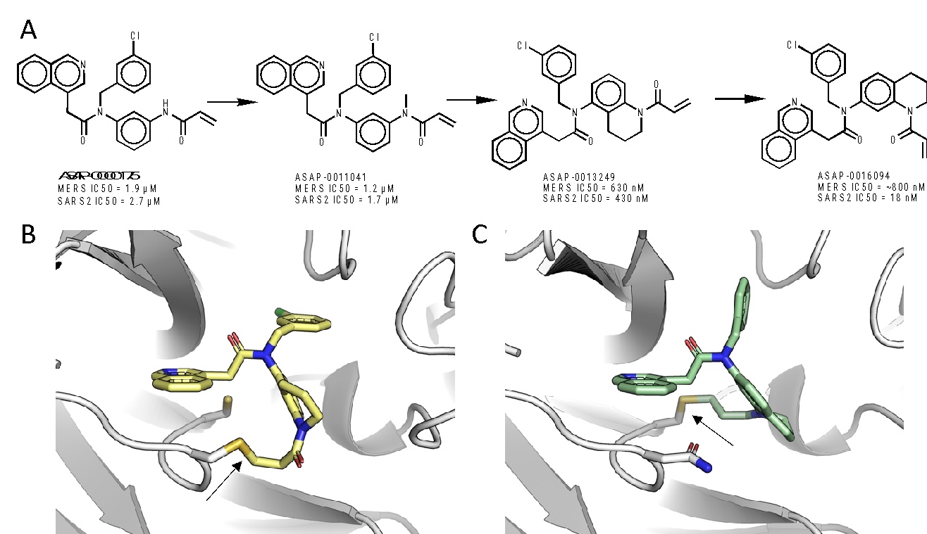

**Figure 3. Dual irreversible SARS2/MERS Mpro inhibitors. A.** The progression of an initial acrylamide derivative of a reversible SARS2 Mpro inhibitor into a dual inhibitor. **B.** Co-crystal structure of MERS Mpro (white) with ASAP-0013249 (yellow), showing a covalent bond formed with Cys145(arrow) but not with the catalytic Cys148 (shown as sticks) **C.** Co-crystal structure of SARS2 Mpro (white) with ASAP-0016094 (green), showing a covalent bond formed with the catalytic Cys145 (arrow).

*B.2. Covalent EV-D68/A71 3C protease inhibitors*

We screened 7,350 electrophilic fragments comprising various ‘warheads’ against the 3C protease of EV-D68 and EV-A71. The primary screen was performed at two concentrations 50 and 100 μM. For EV-D68, we found 55 hits showing over 75% inhibition at 100 μM. For EV-A71 we found 35 hits showing >65% inhibition at 100 μM. We performed full dose response evaluations for all hits at two time points: 15 min. and 2h pre-incubation. Most compounds showed the anticipated shift in IC50 upon longer incubation – a hallmark of irreversible inhibitors. The best inhibitors show <10 μM inhibition (Fig. 4) through a variety of electrophiles. It is interesting to note that some fragments show similar (within 2x) inhibition across both proteases, while other show up to 10x selectivity preference to EVD-68 (Fig. 4). 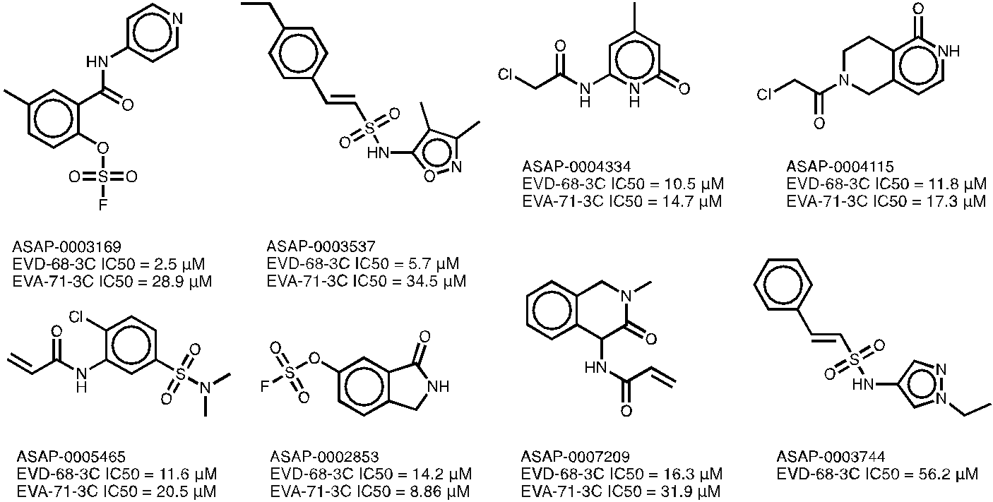

*B.3. Covalent DENV/ZIKV NS2B/NS3 protease inhibitors*

We screened two different types of libraries against the ZIKV, DENV-2, and WNV NS2B/NS3 proteases. The first is a proprietary library collected by the Bogyo lab containing 700 compounds with various electrophiles targeting serine proteases. This resulted in 6,3 and 1 hits for Zika, Dengue, and West Nile respectively. We followed up with full dose response curves. The most promising hit representing the aryl-phosphonate electrophile showed an IC50 of 18 μM for ZIKV but only 270 μM for DENV-2 (Fig. 5; left). A second hit with a less precedented warhead (chlorocumarin) only hit ZIKV (IC50=12 μM) and WNV (64% inhibition at 50 μM).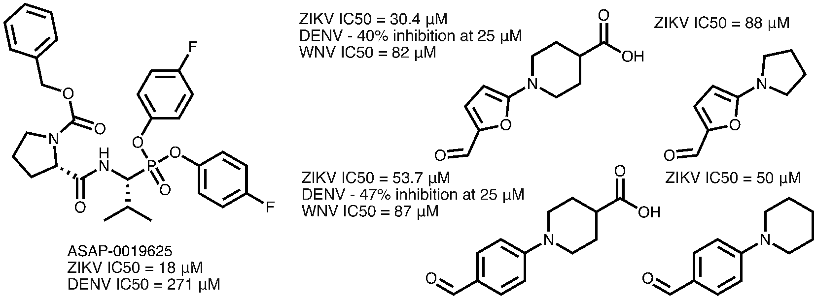

We proceeded to screen a second commercial library of 1,600 serine targeting electrophilic fragments, which resulted in 18 hits (ZIKV), 4 hits (DENV-2), and 15 hits (NV). For ZIKV we determined IC50s for all the hits that ranged from 2.5 μM to ~80 μM. Two aldehyde fragments appeared as hits against all three enzymes (Fig. 5; right), and showed distinct SAR.

*B.4. Covalent EV-D68 2A protease inhibitors*

We screened a proprietary cysteine-targeting electrophile library of 990 compounds against the EV-D68 2A protease, and identified 11 hits, however none of them reproduced in full dose response validation. We next screened a commercial 3,200 cysteine focused commercial fragment library which resulted in the identification of two hit series’: methyl-substituted chloromethyl ketones and chloroacet-dihydro-pyrazoles (Fig. 6). Both series’ reproduced by full dose response, displayed SAR, and formed irreversible adducts as assessed by intact proteins LC/MS.

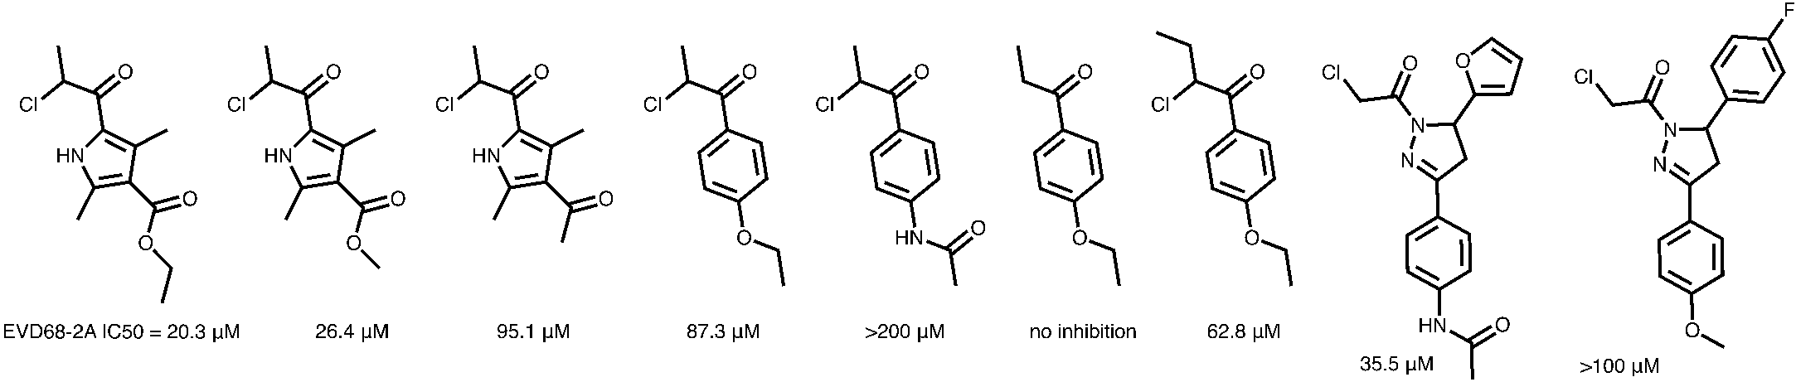

**Figure 6. Two electrophile fragment series’ identified for EV-D68 2A protease.**

*B.5. SARS-CoV-2 Mpro PROTACs*

We set out to design targeted PROTAC degraders for SARS-CoV-2 Mpro, aiming to achieve more potent cellular anti-viral effects. We based our initial design on a moderately potent SARS-CoV-2 Mpro binder— ASAP-0000221 (IC50=28 nM; EC50=2.3 μM) (Fig 7A). For the E3 ligase recruiting, we chose Cereblon (CRBN) as its recruiters display much better PK properties. We designed seven linkers and tested them biochemically and in cells. Three of the linkers maintained biochemical potency (losing only 2-6 fold), but none were potent in cellular antiviral assays. We hypothesized this might be due to poor permeability, to verify, we next made three compounds based on a more advanced Mpro binder (Fig 7A; bottom), two of which showed 6 and 12 nM potency biochemically, but still very poor cellular activity.

To address cellular activity in a faster way (than anti-viral assays) we set out to generate a stable Mpro reporter cell-line. We engineered a SARS-CoV-2 Mpro (nsp5)-EGFP fusion protein to monitor the levels of Mpro within live cells following treatment with our PROTACs. The close proximity of the N- and C-termini of SARS Mpro to the active site and the dimerisation site meant that standard insertion of the EGFP protein to either of the termini was not possible (PMID: [32402186](https://pubmed.ncbi.nlm.nih.gov/32402186/)). We therefore identified disordered loops in the protein and selected a point of insertion that was less likely to interfere with protein folding and enzymatic activity (Fig. 7B). Upon transfection, ubiquitous EGFP fluorescence was visible throughout the cell, reflecting previous reports that SARS Mpro is localised to both the nucleus and the cytoplasm (PMID: [35075101](https://pubmed.ncbi.nlm.nih.gov/35075101/)). The presence of EGFP was further confirmed by detection in western blot analysis of the transiently transfected cells (Fig. 7C). We co-transfect the cells with mCherry to normalize for viability. These cells will be used for rapid PROTAC profiling (Fig. 7D). 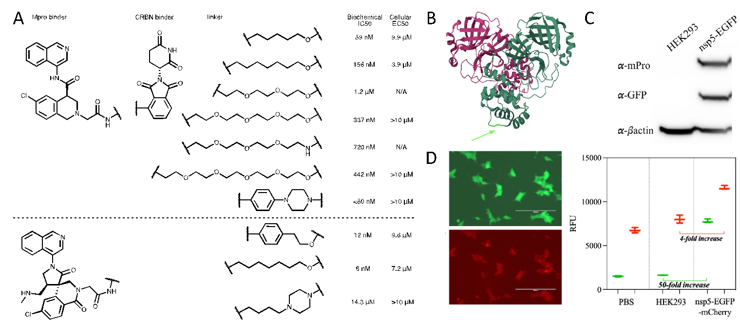

**Figure 7. Development of PROTACs for the SARS-CoV-2 Mpro protease. A.** Structures and activities of first (upper) and second (lower) generation Mpro PROTACs **B.** Structure of Mpro; green arrow indicates flexible loop into which we grafted EGFP. **C.** WB analysis showing transient transfection of Mpro and GFP **D.** Left:EGFP and mCherry detected using fluorescent microscopy in stable nsp5-EGFP-mCherry HEK293 cell line. Magnification: 10x, Scale bar: 200 μm. Images show representative cells. Right: Comparison of EGFP and mCherry fluorescence in PBS, HEK293 and stable nsp5-EGFP-mCherry cell line.

*B.6. Covalent peptides targeting SARS-CoV-2 spike protein*

We developed a phage display method to identify lead molecules that specifically target the SARS-CoV-2 spike protein through covalent binding interactions that block ACE2 binding and viral entry. This involved optimizing a linker containing a reactive electrophile that induces formation of cyclic peptides by reaction with two cysteine residues on the peptides expressed on surface of the phage. We developed a phage panning strategy in which we perform positive selections using the biotinylated full-length SARS-CoV-2 spike protein to identify covalently bound phage by using stringent washing conditions. After three rounds of positive selection, we perform parallel negative selections in which the ACE2 binding site on spike is blocked by a covalent antibody fragment. We then developed and implemented a data analysis pipeline that allows rapid processing of raw sequencing results from each round of positive and negative selection to identify optimal binding peptides. The list of potential hits was then clustered into groups based on similarity in sequences and chemical properties. This allows us to select top binders from each cluster and synthesize a relatively small number of molecules. We chose a total of 37 sequences that showed high enrichment in positive selections and low enrichment in negative selections (**Fig. 8**). We synthesized the linear peptides containing an alkyne tag on the N-terminus and performed cyclization reactions with the OSF linker to generate the final covalent cyclic peptide products. We tested the set of cyclic peptides for covalent binding to spike and for their ability to block binding between the ACE2 protein using an ELISA readout. From this analysis, we identified multiple peptides that both blocked binding of ACE2 and covalently labeled spike. One of these peptides, one showed inhibition of authentic SARS-CoV-2 virus infection with highest potency against the omicron BA1 variant and reduced activity against the BA5 variant (**Fig. 9**). This difference in potency for the variants suggest that our optimal hit is binding to spike in a highly selective way. We plan to test the molecule against the BA2 variant in the near future because the original phage panning was performed on the BA2 spike protein. We will also focus on optimization of the lead molecule by identifying sites on the cyclic peptide that can be modified with non-natural amino acids to increase potency of binding. We will also add a fluorine molecule to the aromatic ring of the electrophilic warhead to increase reactivity and further increase the potency of the lead molecule. This will hopefully generate an inhibitor that potently and rapidly targets all the omicron variants and potentially other mutants of spike.A diagram of different colored squares

**C. Significance**

C.1. Methacrylamides and sulfamate acetamides have not progressed yet into the clinic, the process we describe to achieve at a 12nM Mpro inhibitor by high-thruput screening of methacrylamides can serve as a template for future campaigns, and will garner much interest in the field. If we would be able to further advance this series into pre-clinical studies in the future, it would unlock a new potential covalent warhead with great implication for the field of covalent drug discovery, expanding our repertoire of possible electrophiles.

As for sulfamate acetamides, there is little known about this emerging electrophile, and while we will currently not pursue it in the context of this series, our reactivity profiling and biochemical data provides an important resource for the community and would guide future drug development using this electrophile.

Regardless, of further development, the new recognition moieties discovered in both of these series constitute new ‘solutions’ to bind to SARS2 Mpro sub-pockets and can inform future generations of SARS2 medicine.

C.2. Our dual irreversible SARS-CoV-2/MERS-CoV Mpro inhibitor series is uniquely differentiated from both our lead reversible assets as well than other available Mpro inhibitors. In particular it is one of the only irreversible covalent inhibitors for these enzymes, though not profiled yet, it is likely to be broader spectrum than just these two strains, and importantly, the fact it lacks any hydrogen bond donors predicts these compounds are likely to be brain penetrant – a unique and coveted property for COVID therapeutics. The irreversible nature of these compound confers an additional advantage of decoupling their PK from their PD. Fast clearance, that plagued other Mpro inhibitors, is less of an issue for fast irreversible inhibitors, and might even be a feature, allowing full target coverage but clearance before labeling of any off-targets.

C.3. The success for the covalent fragment screen against the EV-D68/A71 3C proteases is significant since reversible targeting of these enzymes proved challenging so far. With ligand efficiencies of ~0.4 these are some of the most efficient inhibitors for 3Cs and are a promising direction to target the challenging proteases. Further, the number and breadth of these hits may reveal unique binding features to the protease active sites upon co-crystallization. Lastly, the two potent fluorosulfate hits likely target another nucleophilic residue other than the catalytic cysteine (hypothetically this could be the catalytic histidine residue) and thus may represent a new selectivity and resistance profile. Elucidating their exact binding mode and target nucleophile are the subjects of ongoing research.

C.4. Our aldehyde hits against the flavivirus proteases also represent very promising progress. Aldehydes are precedented in approved drugs and therefore, we may be able to progress this series without switching electrophiles (although this will be something we will certainly try). Second, the series shows broad spectrum across all three viruses, whereas the most potent reversible hits we have only target ZIKV. Third, the consistent SAR gives some confidence that binding is mediated mainly by reversible recognition (and thus these are expected to be selective), and finally the fact that the acid moiety in two of the hits is tolerated but not necessary, suggests this scaffold can be directly applicable to optimization via high-throughput amide coupling.

C.5. Despite the lack of cellular potency for our Mpro PROTACs, the fact that we were able to generate low nM biochemical inhibitors is promising, and points to permeability as the bottleneck for further development. There has been marked advancement in the understanding of PK for PROTACs (PMID: [37708797](https://pubmed.ncbi.nlm.nih.gov/37708797/)) and this should be eminently solvable. The potent biochemical activity is especially promising on the background on recently reported mediocre Mpro PROTACs. (PMID: [38064654](https://pubmed.ncbi.nlm.nih.gov/38064654/),[38394929](https://pubmed.ncbi.nlm.nih.gov/38394929/))

C.6. While the potency of our covalent cyclic peptides targeting the SARS-CoV-2 spike protein is still lacking, as a proof-of concept for the approach this is a significant demonstration for its utility against a real-world target, and underscore it as a potential platform for many viral extracellular targets. Continued development of the technology would surely progress the potency of hits in future campaigns to progress to viable therapeutic candidates.

**D. Plans**

D.1. The drop-off between biochemical activity and cellular activity for ASAP-11656 suggests it may suffer from cellular permeability issues. We will profile it and analogous compounds for permeability and design new compounds with improved permeability based on our learnings from our lead non-covalent SARS-CoV-2/MERS-CoV series. In particular the glycine amide moiety might be a fruitful site for optimization, in which a transition to an oxazole improved the properties of non-covalent compounds. We will not pursue further the sulfamate series due to more promising assets at the moment against SARS-CoV-2 Mpro.

D.2. Our covalent Dual SARS-CoV-2/MERS-CoV Mpro inhibitors are on the verge of passing the threshold criteria to transition to P5 (lead optimization). The irreversible mode of action complements nicely our current assets. The main translational barrier for this series is its metabolic stability. We will profile the metabolic stability of additional compounds in the series, and perhaps perform a metabolic ID study to understand the metabolic liabilities. Upon solving the metabolic issues, we expect this series to progress in the third year of this grant to lead optimization as a backup dual SARS-CoV-2/MERS-CoV inhibitor. Utilizing our co-crystal structures, we are confident we’d also be able to drive potency further to reach significantly better cellular activity. We may also employ methacrylammides to further derivatize these.

D.3. For our covalent EV-D68/A71 3C inhibitors, we will strive to determine their co-crystal structures in complex with our recently identified covalent fragments. This would expedite their hit-to-lead process. During their optimization we will focus on maintaining their favorable physical properties. 3C protease is already known to be druggable by Rupintrivir, but its poor physiochemical properties prevent its further development. We will follow up development of the lower reactivity fragment series’ namely the fluorosulfates ASAP-3169, and ASAP-2853, the beta-substituted vinyl sulfones ASAP-3537 and ASAP-3744, and the acrylamide ASAP-7209. The other fragments might inform optimization of the compounds, but are likely too reactive for follow-up.

D.4. For both the DENV/ZIKV NS2B/NS3 proteases and the 2A proteases, the identified fragments discovered by covalent screening feature electrophiles that are less (if at all) precented in drugs. We would explore electrophile swaps to more traditional ‘warheads’, something that might be easier once we acquire structural data on these fragment binding modes. For both these classes of targets we would also employ a second strategy of ‘covalentization’ of already discovered reversible binders. For ZIKV protease there are now co-crystal structures with sub-μM binders that we might be able to install covalent warheads on. For 2A just recently ASAP released the results of a reversible fragment screen, with fragments binding in the active site, that offer vectors to covalently target the active site cysteine.

D.5. We will validate our stable SARS-CoV-2 Mpro reporter cell line with positive control PROTACs reported in the recent literature. Once validated we will use it to screen additional linkers. Enamine now offers pre-plated PROTAC linker libraries. We will use our nanomole high-throughput parallel chemistry capabilities to generate crude PROTAC libraries and screen it via this cell line. We aim to reach single digit nanomolar degradation in cells which should translate to potent antiviral cellular activity. If this approach works, we would apply it to our discovered Mac1 binders as well, which should differentiate it from the currently reported inhibitors.

D.6. For lack of space in the progress report, we did not provide details on our covalent docking computational efforts which largely did not bear fruit so far, we have prospectively tested compounds predicted by covalent virtual screens, but could not find useful hits. We will continue to improve our docking technology, mainly by increasing library sizes (as has become the state of the art for non-covalent docking). For other targets, such docking efforts were able in the past to ‘skip’ hit-to-lead and provide bona-fide leads directly from docking which will be our aim in the coming year.

D.7. Nanomole high-throughput chemistry proved useful in several hit-to-lead campaigns (PMID: [37943932](https://pubmed.ncbi.nlm.nih.gov/37943932/), [35912476](https://pubmed.ncbi.nlm.nih.gov/35912476/)) including currently for the SARS-CoV-2 Mpro methacrylamides and for a reversible ZIKV protease inhibitor. It also had it challenges with libraries that failed to either synthesize or produce hits (carbamate and urea libraries for flavivirus proteases). We will continue to pursue new chemistries and expand our building block collection to support hit-to-lead and lead-opt efforts across projects 3, 4, and 5.